Task-1:

Create an Index.html and Styles.css files.

Paste the following code to html file.

<!DOCTYPE html>

<html lang="en">

<head>

<link href="styles.css" rel="stylesheet">

<title>Selectors</title>

</head>

<body>

<div>

<p class="line" id="roses">Roses are red.</p>

<p class="line" id="violets">Violets are blue.</p>

<p class="line" id="sugar">Sugar is sweet.</p>

<p class="line">And so are you!</p>

</div>

</body>

</html>

Now style the html file using <div>, class and id by following instructions:

* Align them all center with a border. (use div)
* Space each line equally and underline all the lines. (use class)
* Finally do the following. (use id)
  + "roses" -  red
  + "violets" -  violet
  + "sugar" -  beige

Output:

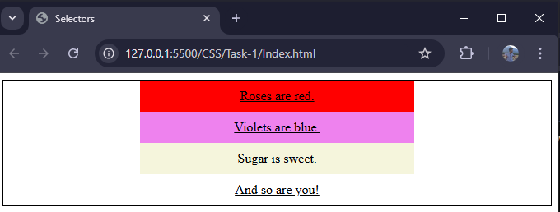

Task-2:

Create an Index.html and Styles.css files.

Paste the following code to html file.

<h2>Continents 🗺️</h2>

    <ul>

        <li>Africa</li>

        <li>Antarctica</li>

        <li>Asia</li>

        <li>Australia</li>

        <li>Europe</li>

        <li>North America</li>

        <li>South America</li>

    </ul>

    <h2>Oceans By Size 🌊</h2>

    <ol>

        <li>Pacific</li>

        <li>Atlantic</li>

        <li>Indian</li>

        <li>Antarctic/Southern</li>

        <li>Arctic</li>

    </ol>

Do the following inside of the **styles.css** file:

* Select both the ul and ol list elements and assign a border of 1px solid and a width of 200px.
* Select the ul unordered list and give it a background-color of lightgreen.
* Select the ol ordered list and assign it a background-color of skyblue as well as a color of white.
* Use the > selector and style the li list item inside the ul unordered list with a text-decoration of underline wavy 3px brown.
* Use the > selector and style the li list item inside the ol ordered list with a text-decoration of underline dotted 3px indigo.

Output:

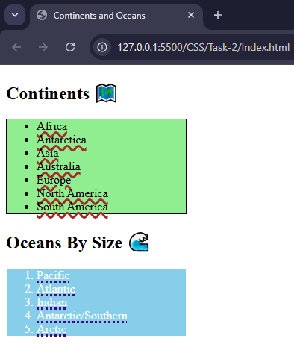

Project-2:

Create an Index.html and Styles.css files.

Let’s make a flyer for a concert that includes a set list for the musical acts!

Refer a concert flyer online and try to recreate or create your own.

Task-3:

Create an Index.html and Styles.css files.

Next, inside the<body>, populate each <h2> heading element with rainbow colors with a unique id:

* Red
* Orange
* Yellow
* Green
* Blue
* Indigo
* Violet

Use at least one named color, one rgb() color, and one hexadecimal.

Output

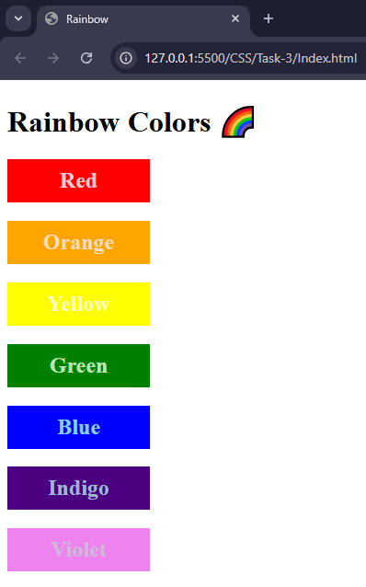

Task-4:

Create a HTML file with following instruction:

* Name the title as measurements, in <body> create to <h2> element with the name Absolute Units and Relative Units.
* Under each <h2> element, create a <img> tag with their respective id’s.
* Select the first image by its id (#absolute) and set its width to 100px.
* Next, select the other image by its id (#relative) and set its width to 50%.
* Save the file and open **index.html** in the browser. Try resizing the window and observe how both images behave as a result!

Output:

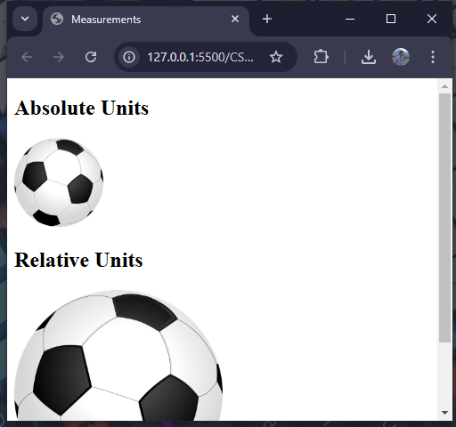

Task-5:

Create a HTML file with following instruction:

Inside body create <p> tag and inside it can be anything you want. It can be as simple as your name, a few sentences, etc.

Then, inside a **Styles.css** file, select the <p> paragraph element and assign it the following:

* A font-family property with a member of one of the five families (don't forget a fallback font).
* A font-size property; feel free to use either absolute units or relative units!
* Save the files and open **index.html** to see what the rendered result looks like.

**Bonus:** Try experimenting with different font families and incorporate the font-weight property, as well.

Task-6:

Create an Index.html and Styles.css files.

Paste the following code to html file.

<!DOCTYPE html>

<html lang="en">

<head>

<link href="styles.css" rel="stylesheet" />

<title>Spellcheck</title>

</head>

<body>

<h4>The quick <span>brwn</span> fox jumped <span>overthe</span> lazy dogs.</h4>

</body>

</html>

**Note:** You may notice the spelling/grammatical errors in the <span> elements. This is intentional.

Next, inside of a **styles.css** file, do the following:

* Select the <h4> heading element and center it with the text-align property.
* Select the <span> elements and give them a text-decoration property with the following values.
  1. A line underneath the text.
  2. A wavy style.
  3. The color red.
  4. 2px of thickness.

Output:

